**Terna Engineering College**

**Computer Engineering Department**

Program: Sem VII

[**Course: Artificial Intelligence & Soft Computing (AI&SC)**](https://github.com/Amey-Thakur/ARTIFICIAL-INTELLIGENCE-AND-SOFT-COMPUTING-AND-ARTIFICIAL-INTELLIGENCE-AND-SOFT-COMPUTING-LAB)

**Experiment No. 08**

**PART B**

**(PART B: TO BE COMPLETED BY STUDENTS)**

***(Students must submit the soft copy as per the following segments within two hours of the practical. The soft copy must be uploaded on the Blackboard or emailed to the concerned lab in charge faculties at the end of the practical in case there is no Blackboard access available)***

| Roll No. 50 | Name: AMEY THAKUR |
| --- | --- |
| Class: BE-COMPS-50 | Batch: B3 |
| Date of Experiment: 05-10-2021 | Date of Submission: 05-10-2021 |
| Grade : |  |

**Aim:** To implement McCulloch Pitts Neuron Model for AND/OR functions.

**B.1 Software Code written by a student:**

import numpy as np

def linear_threshold_gate(dot: int, T: float) -> int:

'''Returns the binary threshold output'''

if (dot >= T):

return 1

else:

return 0

# matrix of inputs

input_table = np.array([

[0,0], # both no

[0,1], # one no, one yes

[1,0], # one yes, one no

[1,1] # bot yes

])

print(f'input table:\n{input_table}')

# array of weights

weights = np.array([1,1])

print(f'weights: {weights}')

# dot product matrix of inputs and weights

dot_products = input_table @ weights

print(f'Dot products: {dot_products}')

T = int(input("Enter threshold value: "))

if(T==1):

print("MCCULLOCH PITTS MODEL- OR GATE")

if(T==2):

print("MCCULLOCH PITTS MODEL- AND GATE")

for i in range(0,4):

activation = linear_threshold_gate(dot_products[i], T)

print(f'Activation: {activation}')

**B.2 Input and Output:**

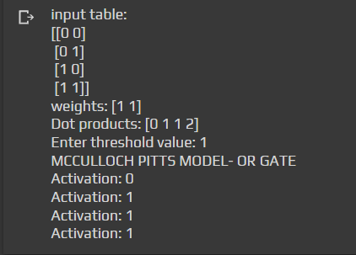

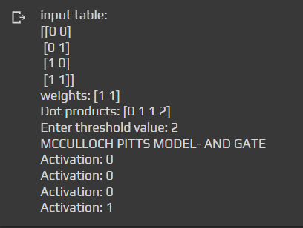

**B.3 Observations and learning:**

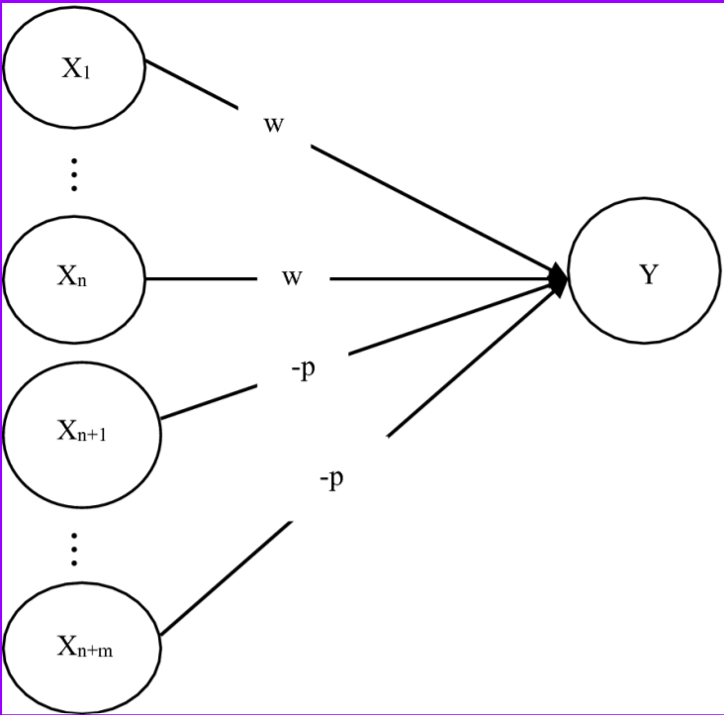

Excitatory have positive weight and which denoted by “w” and inhibitory have negative weight and which is denoted by “p”.

* The neuron fires if the net input to the neuron is greater than the threshold.
* The threshold is set so that the inhibition is absolute because nonzero inhibitory input will prevent the neuron from firing.
* It takes only one step for a signal to pass over one connection link. In this “y” is taken as output and X1, X2…………Xn (excitatory) & Xn+1, Xn+2……., Xn+m (inhibitory) are taken as input signals. The McCulloch Pitts neuron Y has the activation function:

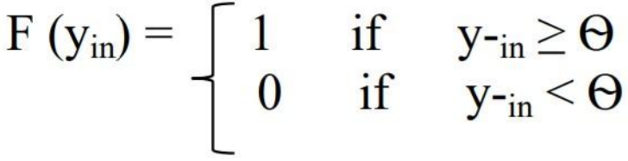

Where Ѳ=threshold Y=net output

**B.4 Conclusion:**

We have successfully implemented a program to learn McCulloch Pitts Neuron Model for AND/OR functions.

**B.5 Question of Curiosity**

***(To be answered by student based on the practical performed and learning/observations)***

**Q1)**

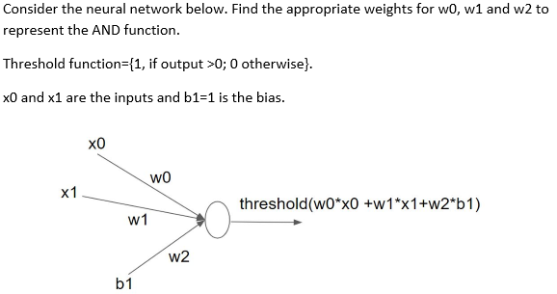

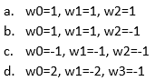

**Ans: b. w0 =1, w1 = 1, w2 = -1**

**Q2)**

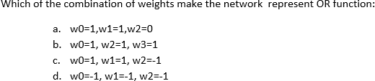

**Ans: a. w0 =1, w1 = 1, w2 = 0**